**ITRW 212 2017**

**Project:**

It is a group (max 2 members) /individual project.

**Topic:** Back to school

Design and create a system that can be used at a school to assist with their tasks.

Examples:

Administration system,

Athletics system,

System to control absentees and detention,

System for Tuck shop,

System for Fundraising events,

System for workers at the school,

System for travelling,

System for the resource center,

Etc.

**Requirements:**

* The entire project must be the student’s own work.
* Individual / 2 members per project
* Must have a graphical user interface
* Suitable classes & a driver (test) class
* Must use at least one interface class and apply polymorphism and inheritance correctly
* Must use at least one text file
* Must use arrays/arraylists and a variety of data types

**Stages of development:**

**Preparation**: Read the example in the Ninth edition of the textbook – Chapter 12 & 13. The complete development of a system for an ATM is discussed in the textbook.

**Phase I: Project proposal (10 Marks)**

**Date: Hand in 17/02/2017**

Hand in a typed document – Cover page & 2 pages

This document will be used as a reference during each evaluation session as well as during the final demonstration session.

On the **cover page**:

The code of the subject: ITRW 212

The name and student number of the member(s)

The title of the project

The phase e.g. Phase I: Project Proposal

The document must include the following:

**What is the objective of the project? (half page)**

**Draw a context diagram** to illustrate the different “actors” /users and how the user interacts with the system. Example of a context diagram:

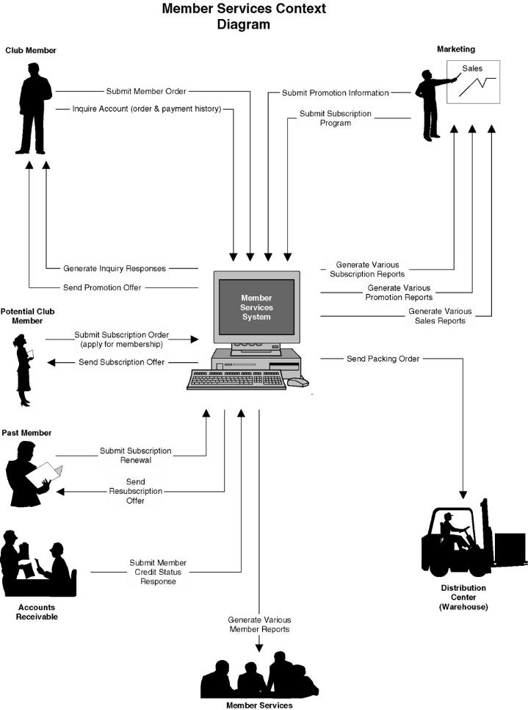

**Flow of events:**

List Activities/options on the menu

Include a short paragraph to explain each activity/option

**Phase II (20 Marks)**

**Date: 10/03/2017**

Phase 1 (The evaluated version of the proposal must be handed in as well). Phase 2 must tie up with what has been proposed.

Show the object classes you have created with inheritance. (5)

Show inheritance and polymorphism (5)

Show the planned layout of the screens and explain the logical flow of events.(10)

**Phase III: (15 Marks)**

**Demo: 17 April 2017**

Phase 1 & 2 must be handed in as well.

Phase 3 must confirm what has been planned in phases 1 & 2.

Demo a prototype of the system. Show the opening screen and flow of events.

The project must be designed in a **user friendly way** from the point of view of the user as well as the system designer.

**Phase IV: (15 Marks)**

**Demo: 9 May 2017**

A prototype of the system – at least 50% of the system must work. Show all the screens electronically.

**Logical flow of events**: User must always know what to do next.

The text file(s) must be created containing relevant data.

**Phase V: (70 Marks) Final presentation**

**Hand in date: 22 May 2017**

The final project must reflect what has been presented during phase 1, 2, 3 and 4

Save this system on a CD or DVD.

Hand in a CD or DVD with all the files to run the program.

**NOTE:**

Your name, subject and the topic of the project must appear on the CD or DVD.

Avoid the use of passwords but if there are any, it has to be supplied in a file on the CD or DVD and in the manual.

Preliminary mark sheet for final evaluation (subject to change):

**ITRW 212 Project 2017 Final Evaluation**

**Topic:.....................................................................................................................**

**Name Student(s) :.................................................................................................**

**................................................................................................................................**

|  |  |  |
| --- | --- | --- |
| Requirements | **Possible**  **Mark** | **Mark**  **allocated** |
| Purpose and goal: Objective accomplished (5) | **5** |  |
| Graphical User interface User Friendly messages(1 – 3)  GUI components well placed (1 – 3)  Good selection of components for purpose (1 – 3)  Logical flow on the screen (1-3)  Logical flow of events (1-3) | **15** |  |
| Code: Structure Inheritance applied well (10)  Used an interface class well (5)  Well designed code – no repetition of code (5)  Make use of a text file, good application (5)  Coding: Level of difficulty (10)  Eye catching or special features (10) | **45** |  |
| Presentation Well prepared | **5** |  |
| Fail if: Another student’s work has been used/presented as your own  The project does not correspond with previous phases  Cannot explain the code/did not code the project yourself  Member who are not present with presentation  Member who did not contribute with programming code |  |  |
| TOTAL | **70** |  |

**...............................................................................................................................**

**...............................................................................................................................**